Vibrations in Digital Watches – Mackenzie Heller

* Digital watches are kept in time by small Quartz vibrating at typically 32.768 KHz.
* Because the Quartz is very sturdy and is not affected by elements such as gravity it’s an extremely accurate method of telling time.
* The Quartz is piezoelectric which means it will vibrate when electricity is put into it
* Quartz is a very common mineral made from silicon dioxide (SiO2).
* The Quartz crystal in a digital watch is usually very small (see diagram below) and is shaped like a tuning fork.

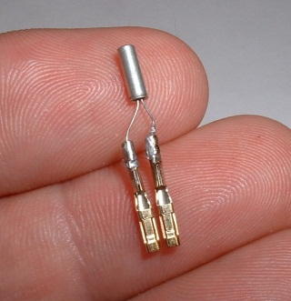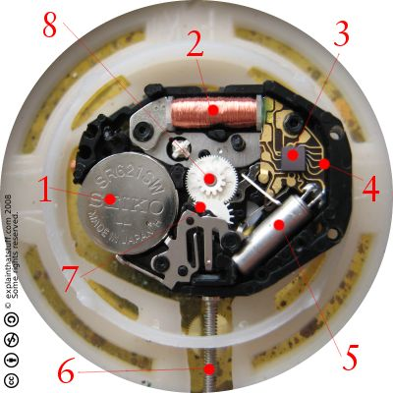

Operation

* A small battery powers a microchip. (1)
* The microchip sends an electrical current though the quartz crystal making it vibrate 32768 times a second. (2)
* The microchip emits one pulse for every 32768 times that the quartz vibrates.(3)
* The pulses power an electric stepping motor which in turn moves the gears of the watch. (4 and 5)
* The gears change the watches interface depending on the type of watch. (6)

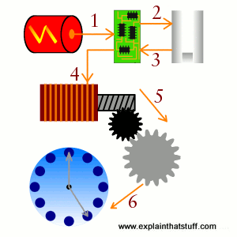

Woodford , C. (2006). *quartz clocks and watches*. Retrieved from http://www.explainthatstuff.com/quartzclockwatch.html

Östman, M. (n.d.). *Silicon dioxide*. Retrieved from http://apps.kemi.se/flodessok/floden/kemamne_eng/kiseldioxid_eng.htm

Maxell, H. (2012). *Silver oxide battery*. Retrieved from http://biz.maxell.com/products/industrial/battery/sr/index.html